Synthesis Printed Chinese Character Image Database（SCUT-SPCCI）

User Manual

Version 1.0



Human-Computer Communication Intelligent Interface Laboratory

School of Electronic and Information Engineering
South China University of Technology

http://www.hcii-lab.net/

Contents

1．Introduction 3
1.1 Descriptions of the Synthesis Printed Chinese Character Image Database 3
2．Descriptions of synthesis gray printed Chinese character image database 4
2.1 CD-ROM file structure 4
2.2 Data format of spcci ccb file 5
2.3 File header structure of spcci ccb 5
2.4 Read format of spcci ccb file 6
3．Instruction of SPCCI CCB file browse instrument (source code attached) 9
3.1 Development environment 9
3.2 Instruction of software 9

1．Introduction

1.1 Descriptions of the Synthesis Printed Chinese Character Image Database
SCUT-SPCCI database is created by the HCII-Lab of South China University of Technology. The SCUT-SPCCI dataset is a synthesized printed Chinese character image database that contains samples of 6763 classes of Chinese characters in the GB2312-80 standard, the standard 10 numerals (0–9), and 52 English alphabets (26 each in upper case and lower case). The database contains synthesized printed character images generated from 280 different fonts. The main technical specifications information of the database is as follows:

- Character set:

- GB2312-80 Chinese characters (6763 characters)
- Ten digitals: 0~9
- 52 capitals and lowercase letters

- # of Fonts: 280

- The size of each gray character image: 64*64

2．Descriptions of data structure of the SCUT-SPCCI database

2.1 CD-ROM file structure
To facilitate the release, SCUT-SBPCCI database is stored in an ISO-9660 format DVD-ROM so that any PC or related equipment which supporting this hardware can read the data on the disc. Figure 1 shows the directory structure diagram of SCUT-SPCCI database.

Data Disk
DOC
DATA
PROGRAM
Fig.1 the data disk directory structure of SCUT- SPCCI database

- Various SCUT- SPCCI data are stored in the corresponding subdirectories under the folder named DATA.
- The description of SCUT- SPCCI file format is stored in DOC directory.
- In the PROGRAM directory, a sample program source code which can read the SCUT- SPCCI data and the corresponding executable file are stored.

2.2 Data format of SCUT-SPCCI ccb file
The extension name of the data file for Synthesis gray printed Chinese character image is ccb. The gray printed Chinese character images, which are stored in the database, can be displayed through correctly reading the file data of SPCCI ccb. The file format of SPCCI ccb is shown in figure 2:

file header
index table
data area
character number
offset of index table
Name of the font
simplified or traditional character set tag
preservation information
character coding value
character data
…………
…………
character address value
Chinese characters save as GBK code, English letters and numbers save as ASC code.
Store offset address value of character data.
64*64 bytes, character data are 8bit gray images with 64 pixel both in height and width
4 bytes
4 bytes, fixed constant 512
50 bytes
10 bytes
444 bytes
6825 items for GB2312, 5463 items for Big5
..., 6825 items for GB2312, 5463 items for Big5
Fig.2 file format of spcci ccb file

2.3 File header structure of SPCCI ccb
typedef unsigned char Byte;
typedef unsigned int Uint;
typedef unsigned short Ushort;

typedef struct CCB_Header // data header structure of ccb file
{
Uint GlyphTotalNumber; // total number of glyphs
Uint IndexTableAddress; // offset of index table address;
char GlyphName[50]; // char glyph name
char SimpleOrTraditional[10]; // GB2312 simplified, GB2312 traditional, Big5 traditional
char PreserveInfo[444]; // preservation information
}CCB_Header;

  - Read format of SPCCI ccb file
- Read file header

void ReadCCBfileHeader(FILE* file, CCB_Header* ccbHeader)
{
fseek(file, 0, SEEK_SET);
fread(&(ccbHeader->GlyphTotalNumber), 4, 1, file); // Read the total of glyphs of the word stock
fread(&(ccbHeader->IndexTableAddress), 4, 1, file); // Read the offset of index table of word stock
fread(ccbHeader->GlyphName, 50, 1, f ile); // Read word stock name
fseek(file, 58, SEEK_SET);
fread(ccbHeader->SimpleOrTraditional, 10, 1, file); // Read the type of character set of word stock
fseek(file, 68, SEEK_SET);
fread(ccbHeader->PreserveInfo, 444, 1, file); // Read the preservation information of word stock
}

- Obtain data of a character

/*obtain data of a character through coding this character (Chinese characters are GBK code, English letters and numbers are ASCII code)*/
bool GetOneGlyphData(Ushort codeValue, FILE* file, Byte* buffer)
{
Uint dataPosition;
Uint glyphCounts;

fseek(file, 0, SEEK_SET); // Read the total number of glyphs of this word stock
fread(&glyphCounts, 4, 1, file);

fseek(file, 512, SEEK_SET);
for(int i=0; i<glyphCounts; i++) // Loop code values of all glyphs, find the matched glyph
{
Ushort indexCode;
fread(&indexCode, 2, 1, file);
if(indexCode==codeValue) // Find glyph
{
fread(&dataPosition, 4, 1, file);

fseek(file, dataPosition, SEEK_SET);
fread(buffer, 64*64, 1, file); // Read glyph data
return true;
}
else
{
fseek(file, 4, SEEK_CUR); // Move pointer of file to the next GBK code
}
}

printf("字形获取：该字形不存在\n");
return false;
}

/* obtain data of character through the index position of this character in the word stock*/
bool GetGlyphByIndex(Uint index, FILE* file, Byte* buffer)
{
Uint glyphCounts;
Uint dataPosition;

fseek(file, 0, SEEK_SET); // Read the total number of glyphs of this word stock
fread(&glyphCounts, 4, 1, file);

if(index<0 || index >=glyphCounts) // Judge whether this index is valid
{
printf("字形获取：该索引超出范围\n");
return false;
}

int offset = 512 + index*6 + 2; // Point pointer to the glyph address value that the index points
fseek(file, offset, SEEK_SET);
fread(&dataPosition, 4, 1, file);

fseek(file, dataPosition, SEEK_SET); // Read glyph data
fread(buffer, 64*64, 1, file);
return true;
}

3．Instruction of SPCCI CCB file browse tool (source codes are given in the CDROM)

3.1 Development environment
Operating platform: Windows XP、Window7
Development tool: Visual Studio 2008
Development language: VC++ 9.0
Using plugins: Codejock Xtreme Toolkit ( for UI design)

3.2 Instruction of software

Main interface of this system is shown as the below picture:

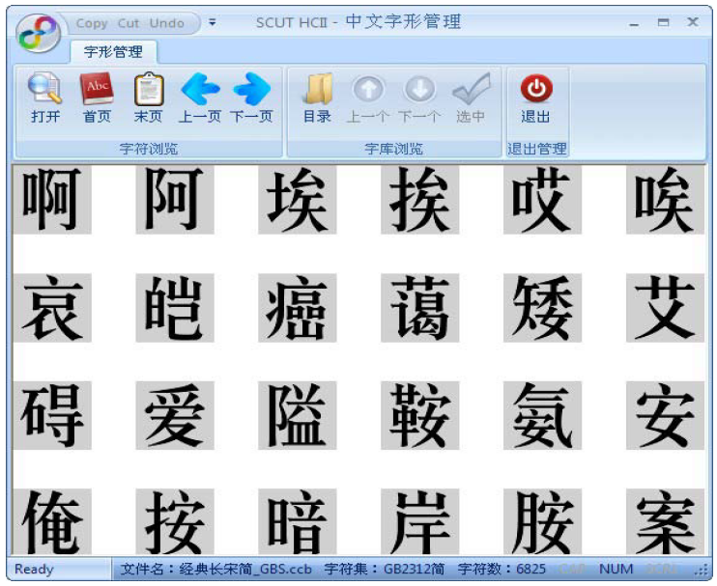
Fig.1 main interface of system

- Character browse
The functional buttons of character browse are shown as the below picture:



Open: click this button, choose one spcci ccb word stock file to be browsed
Home page: showing as paging since there are many characters in one spcci ccb word stock file. Display the characters on the first page.
Last page: display the characters on the last page.
Page up: display the characters on the previous page
Page down: display the characters on the next page

- Work stock browse
The functional buttons of work stock browse are shown as the below picture:



Directory: click this button, choose the directory including spcci ccb word stock file as current directory
Last: check the last spcci ccb word stock file under current directory
Next: check the next spcci ccb word stock file under current directory
Select: select current spcci ccb word stock file and put it into the selected sub-directory of current directory

- Exit system
Press button to exit system

